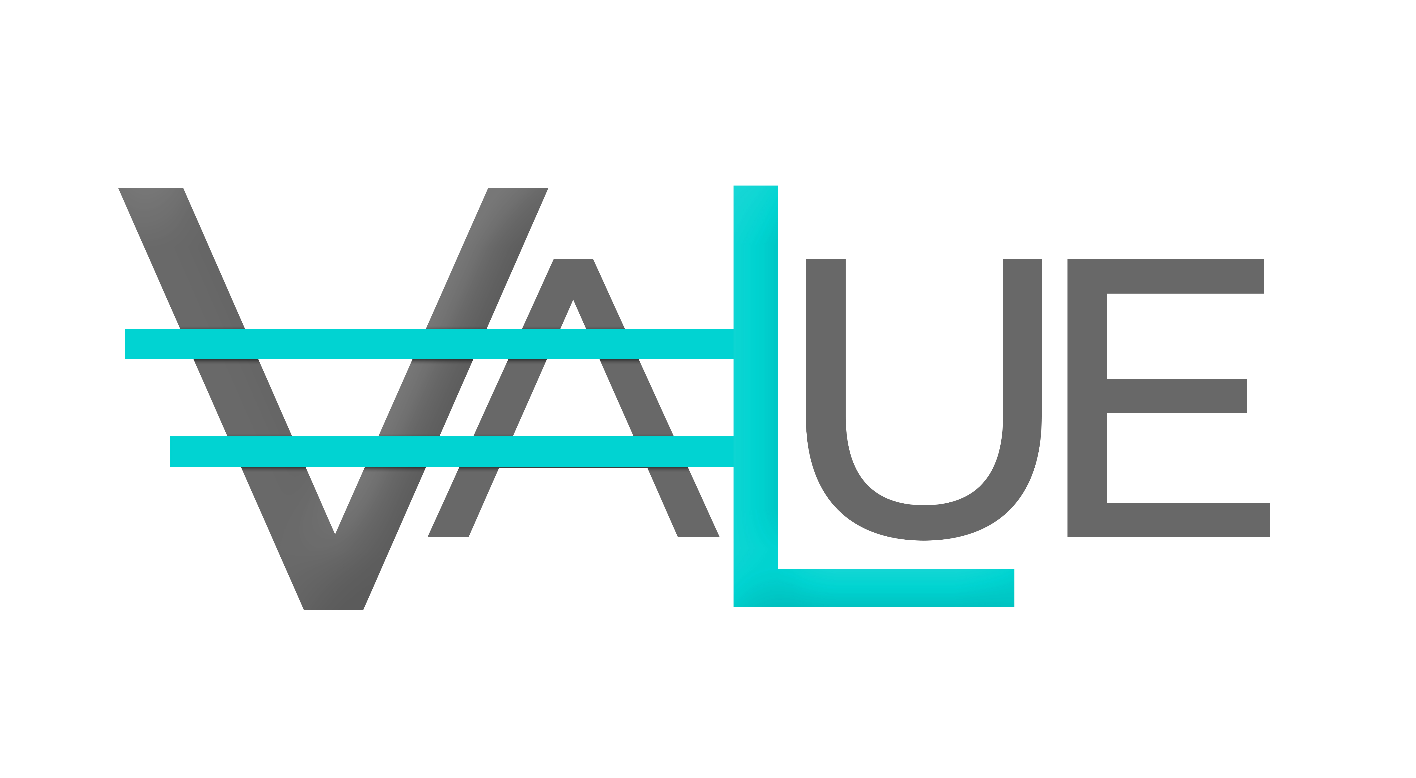VALUEIO INFRASTRUCTURE ROADMAP

Phase 0 — Governance Hardening (0–3 Months)
Structural Readiness
Smart-I-Shelf
• Finalize hardware architecture and enclosure design
• Complete sensor fusion calibration validation
• Confirm telemetry reliability thresholds
HomeSphere.AI
• Stabilize multi-agent routing core
• Enforce contract-based communication schema
• Implement deterministic execution logging
R.E.T.N.A
• Deploy receipt issuance framework
• Implement invariant-check enforcement
• Establish fail-closed authorization doctrine
Milestone Outcome:
Architecture completed. Governance boundary defined.

Phase I — Proof of Infrastructure (3–6 Months)
Validated Prototype + Governance Boundary
Smart-I-Shelf
• Field-ready prototype units
• Real-world telemetry capture
• Physical state verification reliability ≥ defined threshold
HomeSphere.AI
• Multi-agent orchestration across controlled deployments
• Model-agnostic routing under live conditions
• Execution trace generation under load
R.E.T.N.A
• Policy evaluation under live decision cycles
• Immutable receipt issuance validation
• Escalation tier testing (Mode A / B / C)
Milestone Outcome:
Prototype + defensible IP + governance validation.

Phase II — Pilot Validation (6–12 Months)
Operational Deployment
Smart-I-Shelf
• In-field OEM pilot partnerships
• Performance reliability benchmarking
• Closed-loop usage dataset accumulation
HomeSphere.AI
• Multi-device coordination
• Cross-system orchestration validation
• Switching cost indicators forming
R.E.T.N.A
• Governance stress-testing under financial and physical decision scenarios
• Audit trace validation
• Regulatory alignment mapping (EU AI Act, FDA guidance)
Milestone Outcome:
Reference deployments + operational pilot proof.

Phase III — Infrastructure Adoption (12–24 Months)
Entrenchment
Smart-I-Shelf
• Marketplace deployment agreements
• Production hardware scaling
• Integration with appliance manufacturers
HomeSphere.AI
• Embedded orchestration layer within OEM ecosystems
• API-based integration across partner networks
• Revenue-backed SaaS activation
R.E.T.N.A
• Governance licensing framework
• Policy enforcement as a service
• Institutional compliance positioning
Milestone Outcome:
Infrastructure embedded. Integration depth established.

Phase IV — Protocol Standardization (24+ Months)
Ecosystem Dependency
Smart-I-Shelf
• Reference hardware standard
• Cross-manufacturer interoperability
HomeSphere.AI
• Model routing marketplace
• Cross-vertical orchestration support
R.E.T.N.A
• Governance protocol licensing
• Regulatory-ready certification layer
• Cross-industry adoption
Milestone Outcome:
Protocol-level dependency. Governance becomes required layer.

